2026 CSE 60744
Special Topics in Machine Learning and Visual Computing

Vision Caption on Personal Devices with Binary and Sparse Calculation.

Prepared by

Ainjas

University of Notre Dame,

Notre Dame, IN, 46556

Approved by

Yipin Guo
Sixue Xing
Xiaonan Luo

On

Mar. 5. 2026

Captain: Yipin Guo
Sixue Xing
Xiaonan Luo

1. Main Functions and Expected Significance

Machine Learning and vision-language-modeling has been widely used to enable systems to describe visual scenes into natural language, opening the door to assistive technologies for visually impaired individuals. However, for resource-constrained systems, such as PC/laptop, deploying such model faces significant challenges due to limited computation resource and memory. Exploring the use of binary and sparse neural network representations, we present a vision-to-text-to-audio pipeline that efficiently generates real-time audio descriptions of the surrounding environment, providing practical assistance to visually impaired users, allowing them to use current AI technology to gain richer insights into the world around them, giving them another pair of “eyes”

Deploying Vision-Language Models (VLMs) on resource-constrained platforms represents a critical step toward bridging advanced multimodal AI research with real-world usability. Unlike conventional GPU- or cloud-based deployments, personal devices implementations demand careful consideration of computational efficiency, parallelization, and memory optimization. Studying these challenges is academically valuable, as it deepens the understanding of model–hardware co-design and offers insights into how large multimodal models can be adapted to resource-constrained environments without compromising performance.

Beyond technical efficiency, this project carries strong social significance. By enabling real-time image captioning and speech output directly on an resource-constrained device, the system can serve as an assistive tool for visually impaired users. Such applications highlight how cutting-edge research in efficient AI deployment can directly enhance accessibility, independence, and quality of life for disadvantaged groups.

In this project, we use digital flows to accelerate the algorithm, especially the matrix multiplications. We will take both conventional and try to implement novel computing techniques to trade off costs and final accuracy.

2. Rationale and Related Background

We chose this project because LLM/VLM are currently widely used in cloud services but rarely used in personal devices. Using VLM to help visually impaired people gain a better understanding of the world around them has both public and commercial value.

Although many mobile phones currently implement similar features as assistive features for the visually impaired, they typically upload image information to the cloud. Considering that this feature may be used in privacy-sensitive scenarios, using a device without an internet connection will provide users with a more secure experience.

3. Design Hypotheses and Challenges

3.1 Hypotheses:

We hypothesize that a binary-sparse decomposition strategy can effectively reduce the computational and memory footprint of vision-language models (VLMs) while maintaining acceptable accuracy for real-time captioning tasks on resource-constrained systems. Specifically, we posit that:

- Binary weight matrices can serve as a low-precision backbone, enabling the replacement of costly floating-point multiplications with efficient addition and subtraction operations, thereby significantly accelerating inference.
- Structured sparse residual weights can compensate for the representational loss induced by binarization, preserving model expressivity without reintroducing prohibitive computational overhead.

These hypotheses are grounded in prior work on binary neural networks and structured sparsity, which have shown promise in other domains such as image classification and object detection. We aim to extend these techniques to multimodal vision-language tasks and validate their efficacy in an end-to-end assistive technology pipeline.

3.2 Challenges:

Despite the potential benefits, several significant challenges must be addressed to realize this vision:
- Accuracy-Robustness Trade-off:
Binarization and sparsity introduce approximations that can degrade model performance. Maintaining caption quality and semantic coherence under aggressive compression remains a non-trivial optimization problem.
- Real-Time Processing Constraints:
The system must process video frames and generate audio descriptions with low latency to be practically useful. Balancing throughput, power consumption, and accuracy under real-time constraints is a key systems challenge.
- Generalization Across Environments:
The model must perform robustly in diverse visual environments (e.g., varying lighting, occlusion, and scene complexity) without frequent recalibration or excessive power draw.
- Deployment and Usability:
Integrating the full pipeline—vision capture, model inference, and speech synthesis—into a cohesive, user-friendly device that operates standalone (without internet) requires end-to-end system design and validation.

Addressing these challenges will require iterative experimentation, close collaboration between algorithm and hardware teams, and rigorous evaluation across both accuracy and efficiency metrics.

Furthermore, given the difficulty and uncertainty of custom hardware, we chose to deploy a Jetson Nano as a fallback solution when specialized hardware is unavailable. Although binary and sparse computations still benefit from memory usage on general-purpose devices, the computational speed advantage requires careful operator design, and the power consumption advantage is lost.

3.3 Most Critical Challenge:

Among all anticipated challenges, the accuracy-robustness trade-off under aggressive binary-sparse decomposition represents the most critical risk to this project. While deployment and latency challenges have known mitigation strategies , maintaining semantic coherence in generated captions after binarizing the vision-language model's linear layers has no guaranteed solution. Vision-language transformers are substantially more sensitive to low-bit quantization than convolutional models studied in prior binary network literature, as the attention mechanism relies on fine-grained weight differences that binarization may destroy. If the sparse residual component fails to recover sufficient expressivity, caption quality will degrade to the point where the system loses practical value. Therefore, we will prioritize accuracy validation in early iterations before committing resources to hardware optimization.

4. Approach/Demo Plan
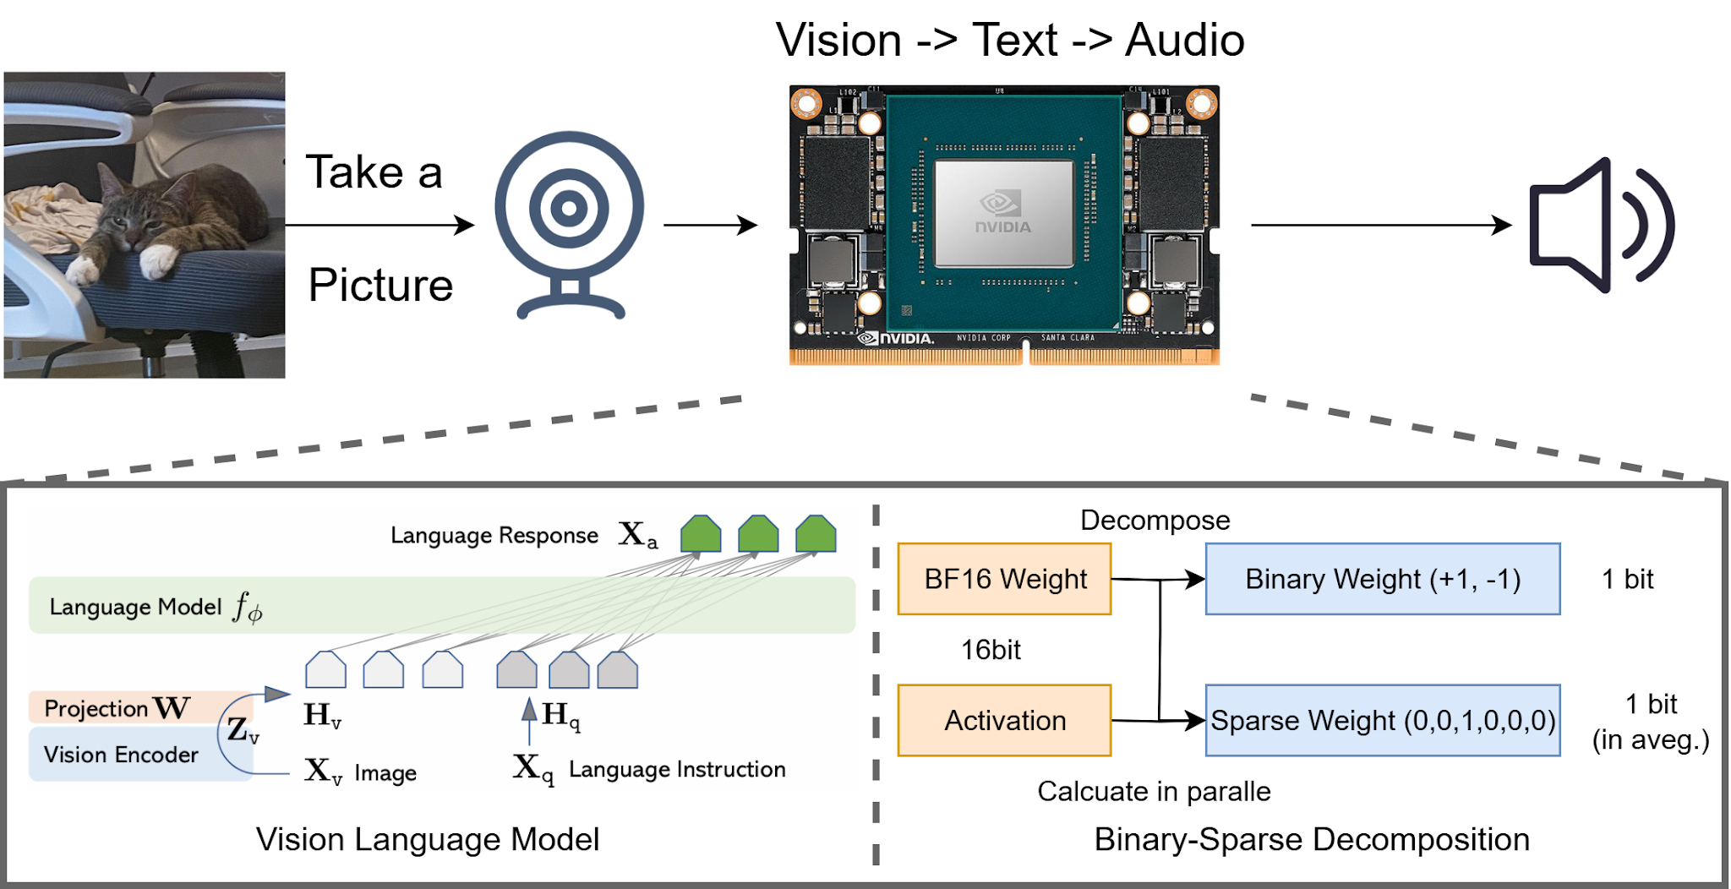

4.1 Core Idea:

We adopt binary-sparse decomposition to reduce both the parameter footprint and the number of costly floating-point operations of all Linear layer in vision language model. By representing weights in binary form and introducing structured sparsity, we maintain sufficient model expressivity while enabling faster and more energy-efficient inference.

Concretely, each linear projection in the VLM is factorized into two complementary components: a binary weight matrix and a sparse weight matrix. An original Bf16 weight will be decomposed in parallel into a 1-bit binary weight and a sparse weight with an average of 1 bit or less.

The binary weight matrix serves as the low-precision backbone of the decomposition. Each entry is constrained to {−1,+1}, which allows multiplications to be replaced by simple additions and subtractions. This drastically reduces the computational overhead, as expensive floating point operations are avoided. Furthermore, binary weights can be stored in a highly compact bit level representation, leading to a significant reduction in memory footprint and improved cache efficiency. Although binary quantization alone tends to degrade model accuracy, it provides a strong efficiency baseline for subsequent fine-grained corrections.
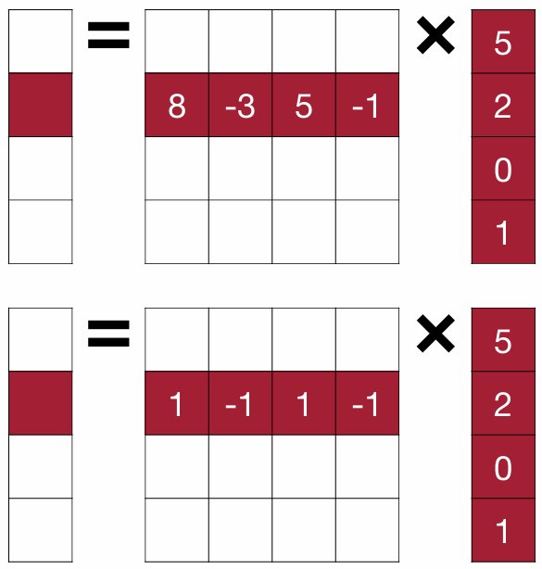
To compensate for the loss of expressivity introduced by binarization, we introduce a sparse weight matrix. This component preserves a small subset of full-precision parameters, arranged according to a structured sparsity pattern (e.g., block or N:M sparsity. The final sparse weights will be represented as a small dense weight matrix and a set of low-bit indices that indicate the position of the weights in a block of size M). The sparse weights act as residual corrections that recover fine-grained information lost during binarization, ensuring that the decomposed linear layer retains sufficient representational power for multimodal reasoning. Because of the enforced sparsity, the number of floating-point operations remains low, and the nonzero parameters can be efficiently accelerated on resource-constrained hardware.
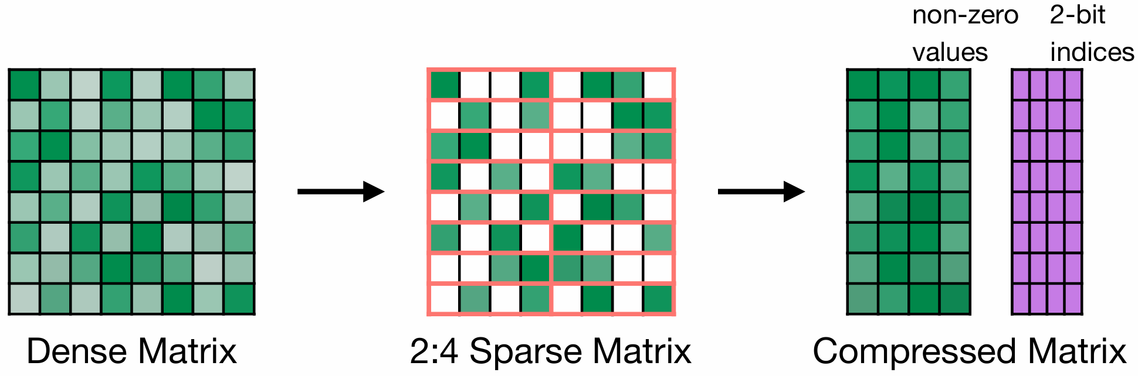

The original matrix multiplication is:
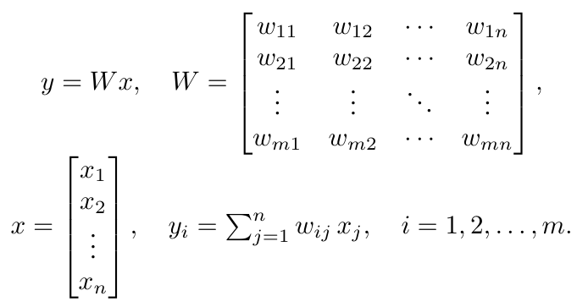
Assuming the shape of weight W is [N, K], the shape of input activation value X is [1, K], the output Y shape is [1, N]. Then completing one calculation requires K*N floating-point multiplications and K*N floating-point additions.

The calculation process for binary matrices of the same size is:
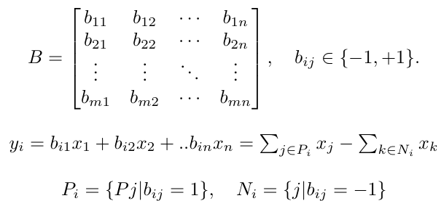
Since all b_{ij} belong to \{-1, +1\}, the calculation is simplified to the addition and subtraction of floating-point numbers, and b_{ij} can be used to determine whether to flip the sign bit of activation. In hardware, the representation value of \{-1, +1\} is stored as \{0, 1\}, so using xnor to process the sign bit of the activation value can quickly complete the processing. Finally, the calculation is simplified to K*N binary xnor and K*N floating-point additions. It avoids expensive multiplications.

As for the sparse matrix, its calculation method is
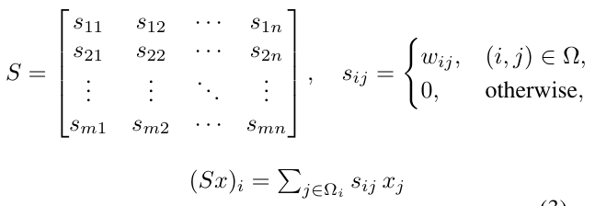
Here we expect to use a structured sparse matrix of N:M, where N is less than M, taking 1:16 as an example. The core of this type of matrix calculation is to use indices to index the activation, read the activation value corresponding to the effective position of the weight, and then perform the calculation. The calculation process is still floating point. However, due to the sparse characteristics, the amount of calculation required is less. Specifically, the calculation becomes K*N/16 floating-point multiplications and K*N/16 floating-point additions.

4.2 Task Break Down:

In this project, we divided our work into two parts: algorithms and hardware implementation. The algorithm team will perform simulated quantization and pruning on the server, test accuracy degradation, and propose better algorithms to maintain model performance.

The hardware team will focus on implementing efficient binary and sparse weight calculations on customized hardware to achieve practical efficiency gains.

• Yipin Guo:
– Lead the project.
– Implementation of quantization and pruning algorithms.
– Experiments design.
– Paper writing.
– Final presentation.
• Sixue Xing:
– Work on algorithm and model implementation
– Model tuning, pruning, binary quantizing, finetune, export, and deploy.
– Paper writing.
– Final presentation.
•Xiaonan Luo:
– Work on algorithm and model implementation
– Model tuning, optimizing, evaluation across benchmarks.
– Paper writing.
– Final presentation.

4.3 How to demo:

In the final week, we will run a visual language model using a PC device with an RGB camera. A webpage button will simulate the capture button being pressed, and then execute the vision caption task, broadcasting the description results through a speaker.

4.3 How to reproduce:

If users want to reproduce this demo on their own devices, they only need to install CUDA and PyTorch in their Ubuntu environment, connect an RGB webcam, ensure a stable internet connection, and then run our codebase. For clearer interaction, we will provide a webpage.

